Phase 3 Deliverables

Below, are the results from the questionnaire conducted for Phase 3, the associated questions, a summary of the questionnaire and what we will be looking to implement going forward.

We also conducted an audio interview which I have attached to the folder. If you have any difficulty opening or playing the audio file, I have provided a brief summary of the interview conducted, highlighting the key criticisms of the app.

Interview Summary:

* Lack of colours in the app. Would make it more engaging if it were more colourful.
* The owl logo should appear on more pages, not just the title page.
* Some pictures that represent the various options and textboxes i.e. mathematical operators for the maths section, a cog for the settings etc
* Boxes around all the text and make them a different colour to the background.
* The login page looks very clinical and would benefit from visual improvements.

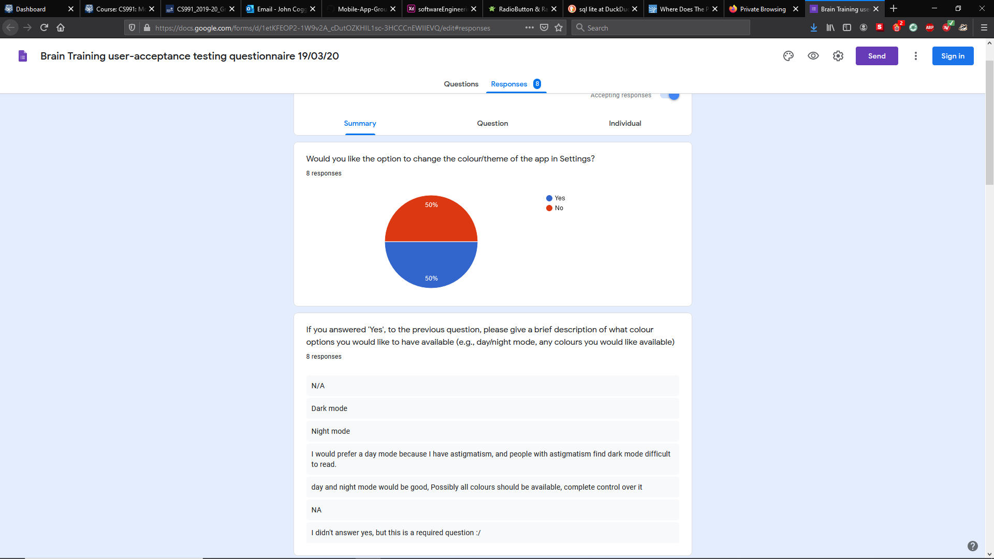

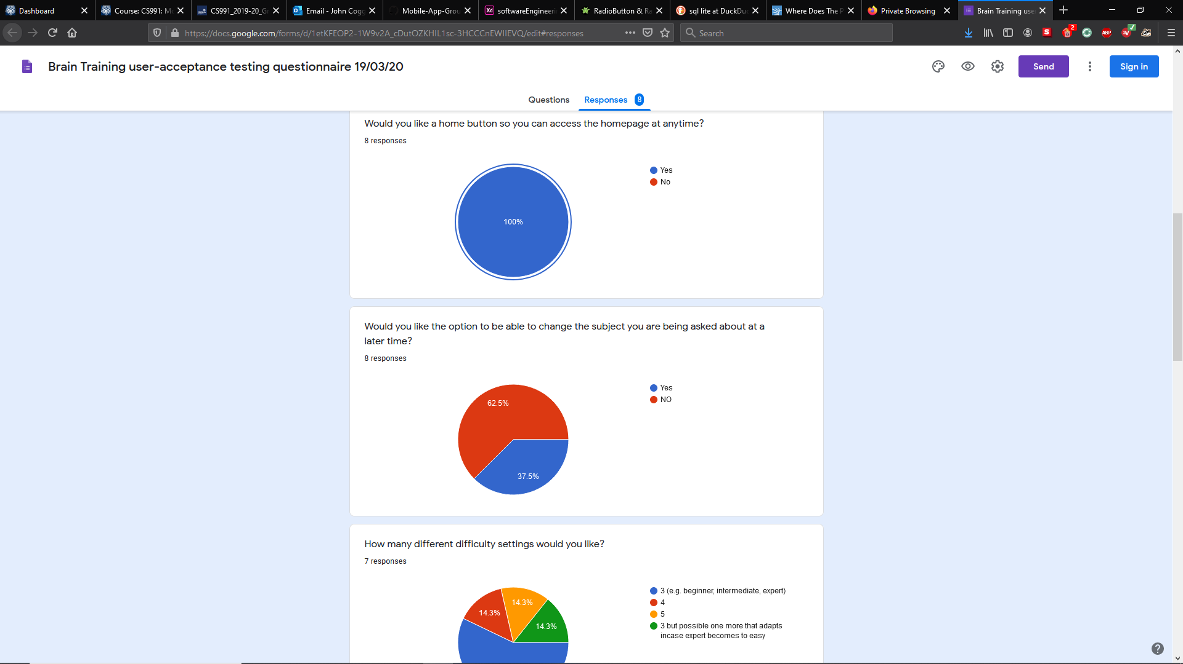

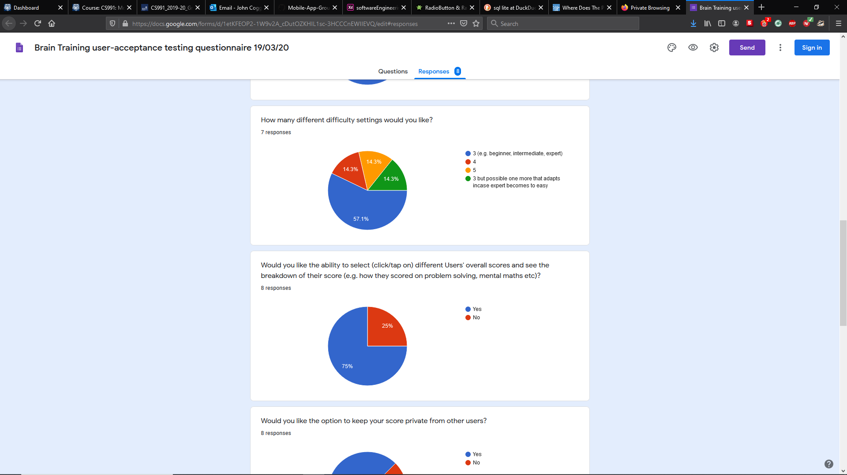

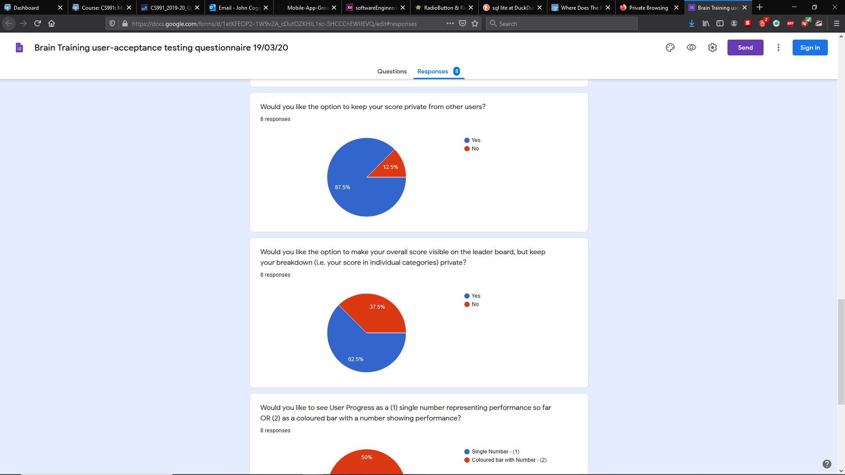

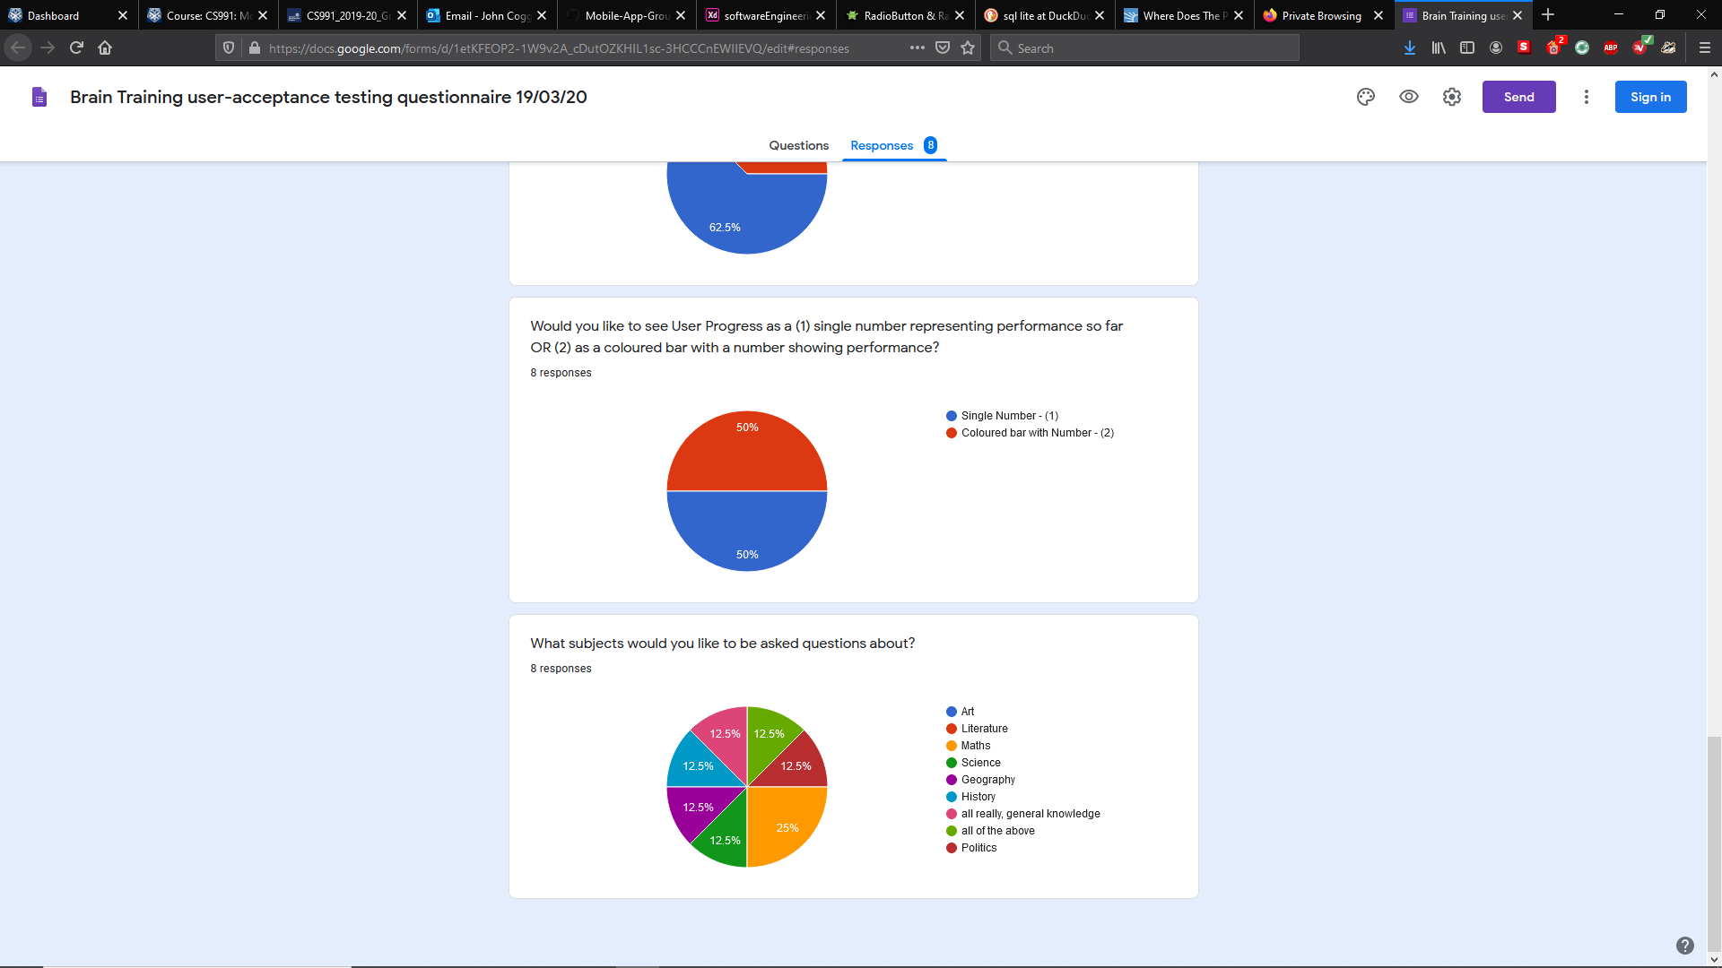

Questionnaire Summary:

Users were split on having the option to change the colour/theme of the app. It appears though, that some those who did want it changed, did so from an accessibility point of view. This would be good to implement later on to ensure no users are knowingly disadvantaged when using the app.

Everyone wanted to have a home button to access the homepage at any time. The majority of users did not want to be able to change the subject they were being asked about at a later time. The vast majority of users only wanted 3 difficulty settings; however, this could impact the range of abilities that are able to benefit from this app i.e. people who have advanced arithmetical abilities would not be able to improve these using our app.

Most users wanted to be able to see the performance of other users. Majority of users wanted to have the option to keep their score private from other users as well as being able to make their score visible to others but not their individual breakdown. Users were split on whether performance should be represented numerically or with graphs.

25% of users wanted to be asked about mathematical questions but the remaining 75% were divided between multiple categories. The main takeaway from this is that to benefit multiple users, we need multiple learning disciplines for them to work on.

Moving forward:

* Improve the visual aspects of the app, colour, images, textboxes etc
* Investigate applying a colour/theme changing setting for potentially visually impaired users.
* Add a home button
* Some way to view other user’s performance but with additional privacy measures for those that don’t.
* Have more variety in terms of questions that can be asked.